Student’s Name

Institution Affiliation
Professor’s Name
Course Date

Problem environment
The new toy playset (crafted as Olympics-the ball is in your court) is set to inspire kids in homesteads to get positively motivated towards Olympics and Paralympics as well.
Stakeholders
- Key stakeholders are children. The children also serve as the primary stakeholders
- secondary stakeholders are parents,
- Tertiary stakeholders are other Olympic participants on which the kids' numbers are going to add on.

Problem statement
- The problem at hand is to design a toy playset that will inspire children to be engaged in sports or other games and competitions. The toy is meant to act as a building block for upcoming imagination and a nourishing incarnation of Scandinavian artistry of something tangible in a pixelated world in the Olympic setup. It aims at dragging the average child from being glued at the TV or the iPad to a purposeful and active way of spending their leisure time and keeping physically fit.

Objectives
Our objective is to design an Olympic toy playset that:
- Has safety mechanisms in place to ensure the toy is not injurious to kids that use it. It should not have sharp corners.
- Material to make it should be very reliable and with a long service period. For this reason, we choose acrylonitrile Butadiene Styrene (ABS) which is a thermoplastic material whose properties are excellent toughness, high durability to ensure the toy has a long service period, high rigidity to keep its shape even in extreme conditions once it’s been formed, good impact resistance to ensure the toy doesn’t break in case of an accidental fall from the shelf its kept when not in use or even when it is in use. Other properties include good insulating properties to cushion against electrical shocks in case of electrical accidents, high surface brightness, and excellent surface aspect to reduce the cost of painting to decorate the toy. The surface shine makes sure the toy is more appealing to children and comfortable working with it. The material has a high dimensional stability and can be distinctly calibrated to operate in a room shared by childhood fantasy with peculiar and parental aspirations.
- Must be of low cost despite the intricate shape. to keep the cost low 3D printing or molding can be used as the manufacturing processes
- It should be safe, particularly with children who are the primary users as their parents are only handlers.
- It should not be detrimental to the environment in that the material should not be a pollutant of the environment in the way it degrades or responds to temperature increase or high pressures.
- It should be aesthetically pleasing to the kids and create the necessary interest in participating in the Olympics and other competitions.

Parts
We use modular design to come up with the respective features then assemble them to make the toy theme. A nominal toy theme is usually 4 cm tall. Parts include:
- Ahead that is cylindrical and attached to a narrow cylinder that acts as the neck and is molded on top of the torso to allow the head to rotate and allow attachment of other items on figures above the torso. The leader needs to be made athlete-like with necessary hairstyles, caps, and hats for different sports depending on the sport we intend to make an influence on, such as hockey. Alternatively, the head can be that of a child to show that kids have the ability to make it in the Olympics as well.
- The torso is the main body on which the head, hips, arms, legs, and hands are assembled to form the entire toy. The toy torso needs to have a close resemblance to a human torso and should be made conforming to a renowned champion who would act as an idol to the children. Necessary sporting clothing can be painted or put on the torso to create a sporting environment for the kids to emulate.
- Hips are connected on the bottom side of the torso and have an unmovable joint between the two hips.
- Arms are connected on the shoulders of the torso and have a revolute kind of joint and a single degree of freedom such that the arm can only be rotated in the forward axis. The arms need to be made in an appealing way giving it a masculine feel to give the right kind of influence to the kids to begin liking sports.
- Hands are C-shaped at the ends and are fixed on the arms.
- Legs need to conform to human legs by a high degree to give the impression of an athlete. The legs rotate 90$°$ forward and 45$°$ backward, which will help create the desired impression about athletes. The designs below can be adopted for manufacture.

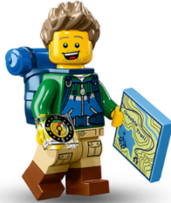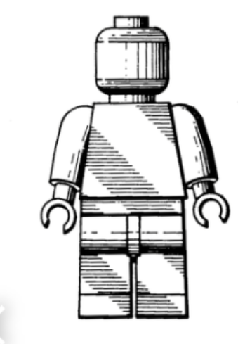

The toy playset theme has seven articulation points for the swivel head, swivel arms, swivel legs, and swivel wrists. This gives a total of seven degrees of freedom for the toy, and it can achieve the necessary motion when the kid operates it.
Light-emitting diodes can be fixed on the head to draw the attention of the children, and some plastic gold-coated medals hang on the neck to impart a winning spirit in the children. Radio devices can also be incorporated into the torso, which says I am a champion running on a rechargeable battery to constantly remind the kids what they can do if they exploited their potential in a different field, such as the Olympics. The voice is to act as an eternal reminder to them every time they play with the toys.

SPORT IDEAS
- For javelin throw, the toy needs to be inclined backwards by 29$°$ with the right hand holding a narrow stick to symbolize a spear and the left hand held ahead of the torso in the position of someone about to make a throw. Necessary clothing is put on the toy to create the feeling of an athlete.
- For marathon the toy set needs to be upright with the legs not as straight as a stationary toy would be. The legs need to be in a running position to give the impression of a marathon runner. Necessary painting on the torso can be incorporated to make the toy look like an athlete or clothed in a vest in the torso and a short on the hips to give the full impression of a runner.
- For badminton the toy should be holding a ratchet-like figure on the right hand and a cork on the left and clothed in a vest in the torso and a short on the hips to give the full impression of a badminton player.

